Litter 1

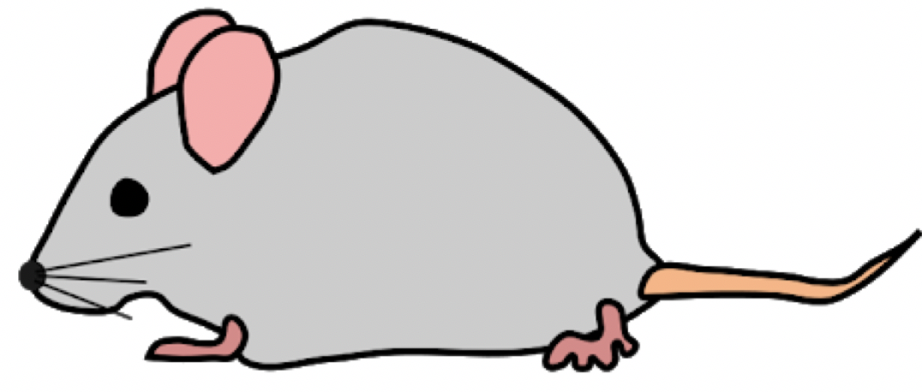

Diet A Diet A



Diet A Diet A



Diet A Diet A

Litter 2



Diet A Diet A



Diet A Diet A



Diet A Diet A

Litter 3



Diet B Diet B



Diet B Diet B



Diet B Diet B

Litter 4



Diet B Diet B



Diet B Diet B



Diet B Diet B

Litter 5



Diet C Diet C



Diet C Diet C



Diet C Diet C

Litter 6



Diet C Diet C



Diet C Diet C



Diet C Diet C

Litter 1



Diet A, S Diet A



Diet A,S Diet A



Diet A,S Diet A

Litter 2



Diet A,S Diet A



Diet A,S Diet A



Diet A,S Diet A

Litter 3



Diet B,S Diet B



Diet B,S Diet B



Diet B,S Diet B

Litter 4



Diet B,S Diet B



Diet B,S Diet B



Diet B,S Diet B

Litter 5



Diet C,S Diet C



Diet C,S Diet C



Diet C,S Diet C

Litter 6



Diet C,S Diet C



Diet C,S Diet C



Diet C,S Diet C

Litter 1



Diet A Diet A



Diet B Diet B



Diet C Diet C

Litter 2



Diet A Diet A



Diet B Diet B



Diet C Diet C

Litter 3



Diet A Diet A



Diet B Diet B



Diet C Diet C

Litter 4



Diet A Diet A



Diet B Diet B



Diet C Diet C

Litter 5



Diet A Diet A



Diet B Diet B



Diet C Diet C

Litter 6



Diet A Diet A



Diet B Diet B



Diet C Diet C

Level 1 Level 2

* Diets assigned - supplements

here assigned here

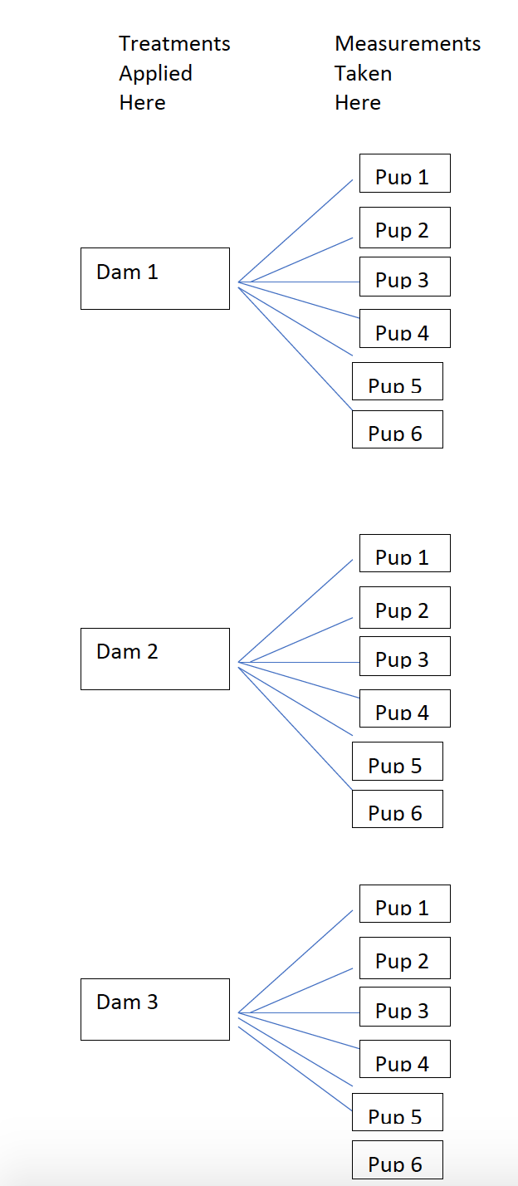

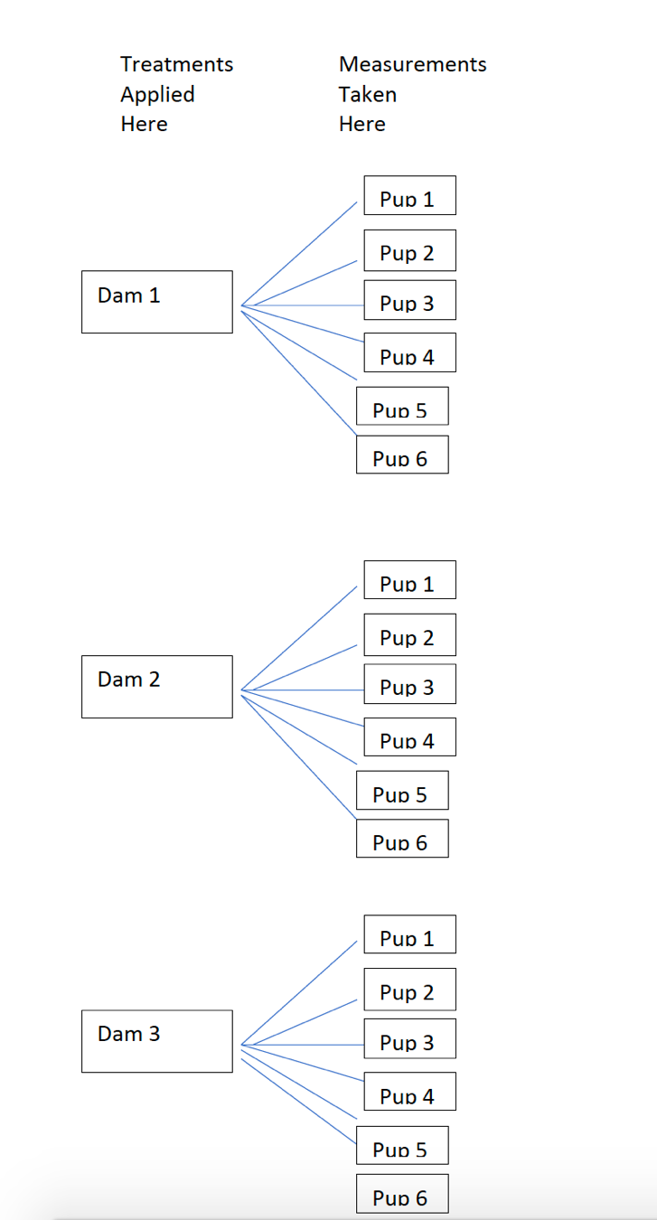

Level 2 Level 1

